

**JUEGO: 16 EMBARCACIONES**

En este ejercicio deberás relacionar los números:

Respuestas:

|  |  |  |  |
| --- | --- | --- | --- |
| (-2) **⋅** (3)+(-4) = **-10**  (-4)-(-2)- (3) = **-5**  (3) - (-4) - (-2)= **9**  (3)**⋅**(-4)÷(-2) = **6** | ((3)**⋅**(-4)) - (2) = **-14**  (-2) **⋅**(3) **⋅**(-4) = 24  (-2) – (-4) – (3) = **-1**  (-4) + (3)+ (-2) = **-3** | (-2) **⋅** (-4)+(3) = **11**  (3) – (-2) +(-4) = **1**  ((3) + (-4)) **⋅**(-2) = **2**  ((-2) + (3)) **⋅**(-4) = **-4** | (-2) **⋅** (-4) - (3) = **5**  ((-4) – (-2)) **⋅** ( 3)= **- 6**  (-2) + ((-4 )- (3)) = **-9**  ((-2)- (3)) **⋅** (-4) = 20 |

-9

-6

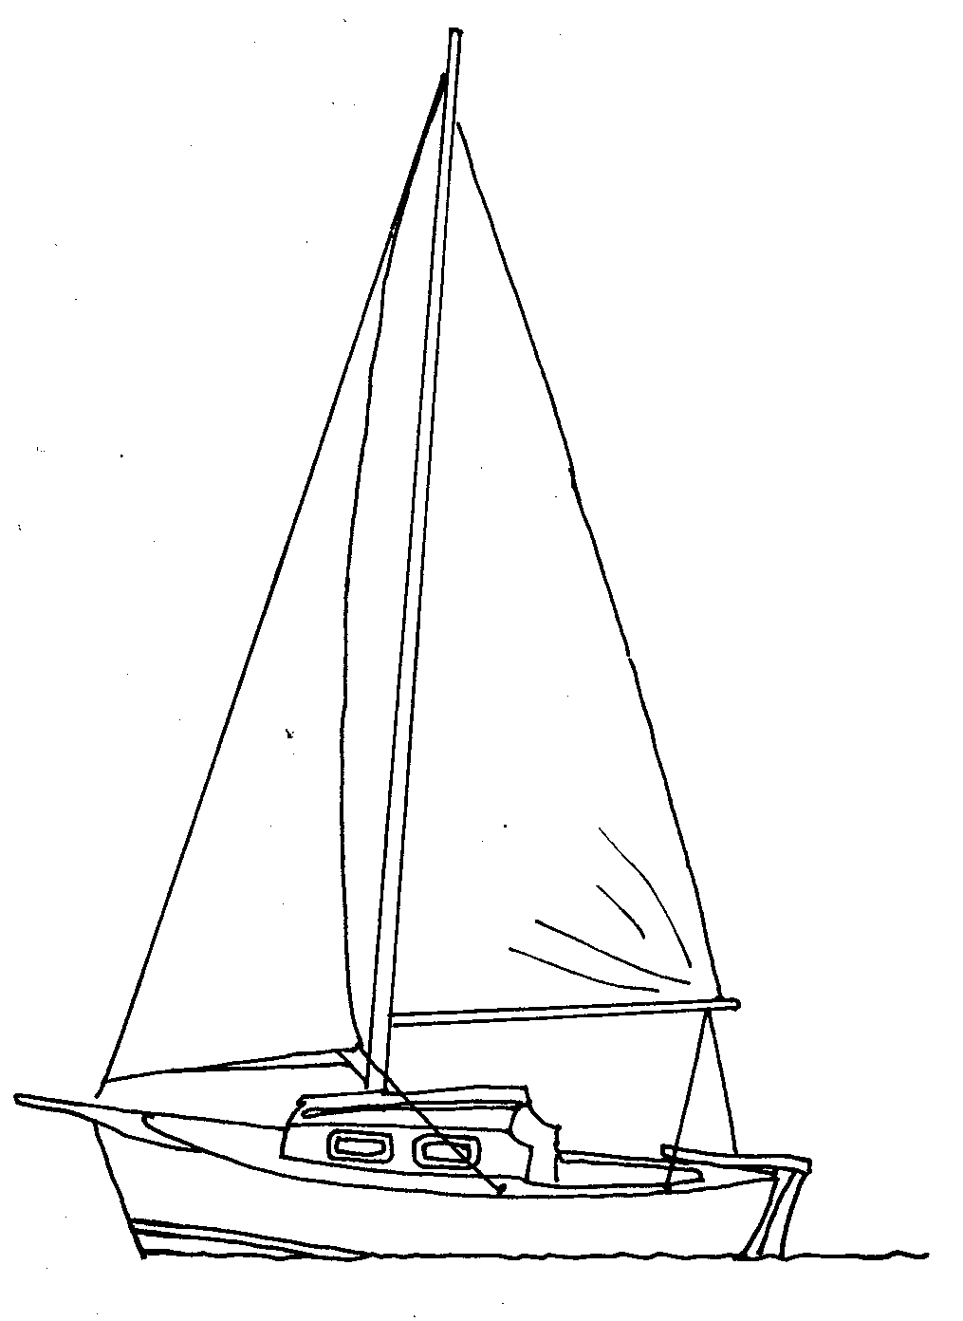

__________________-_____________________-_____________________--

1

20

-5

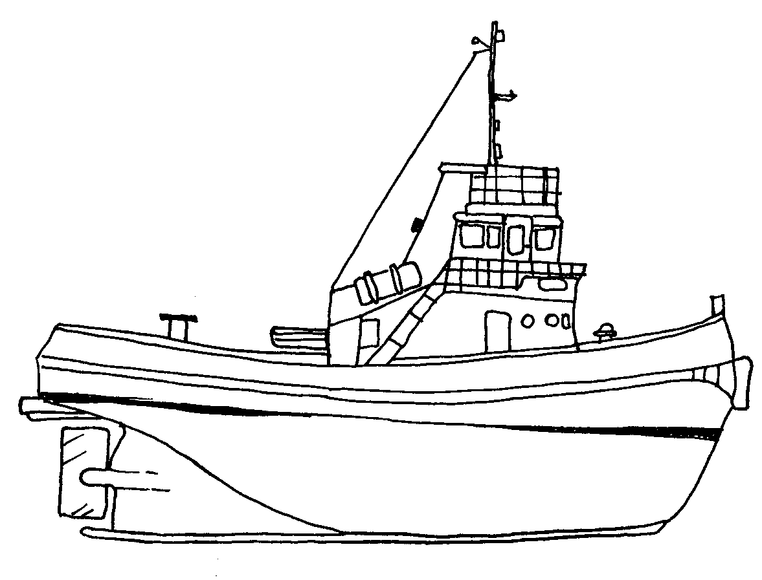

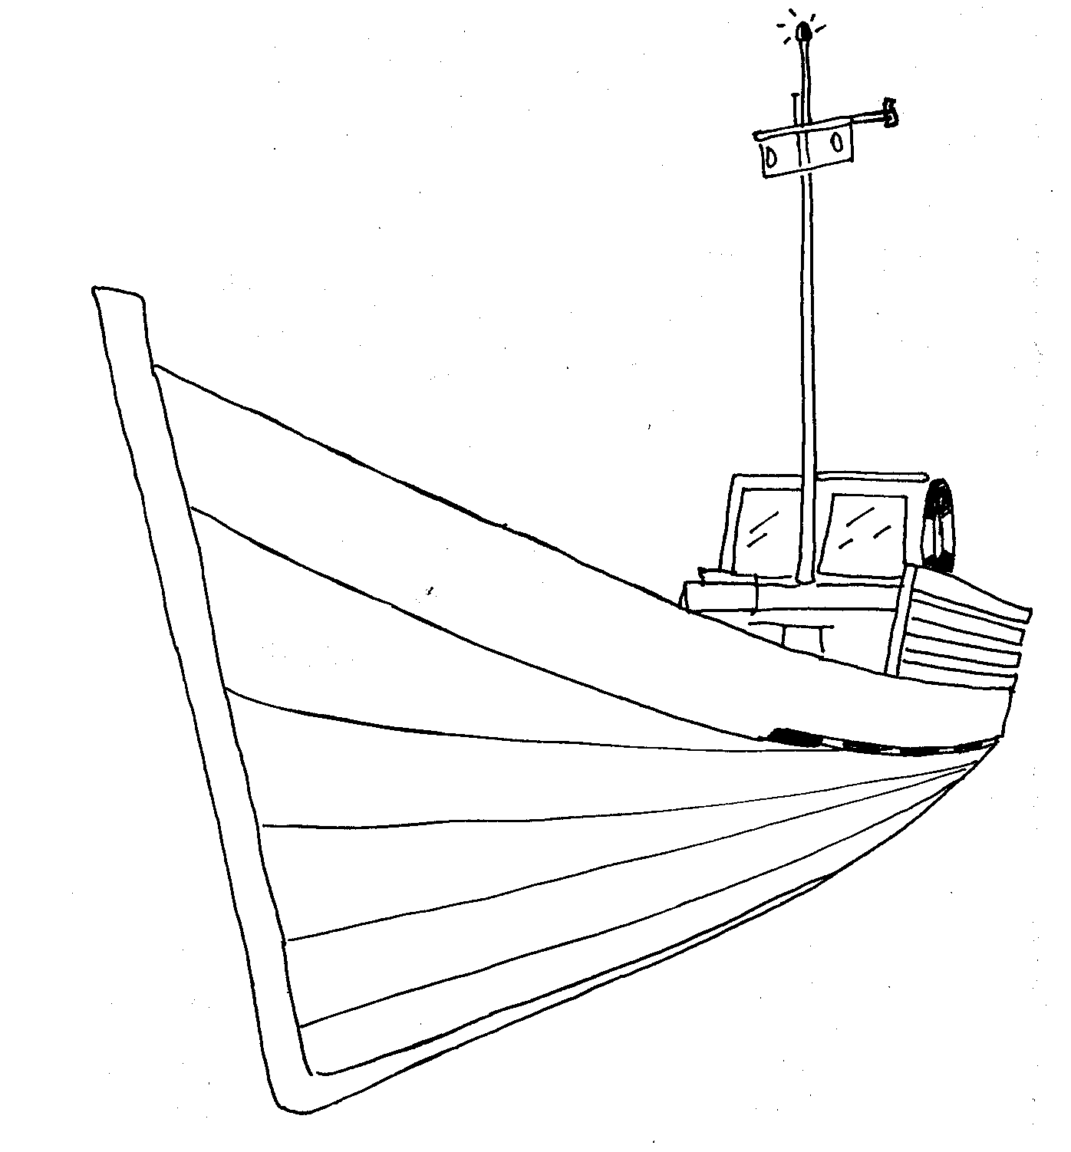

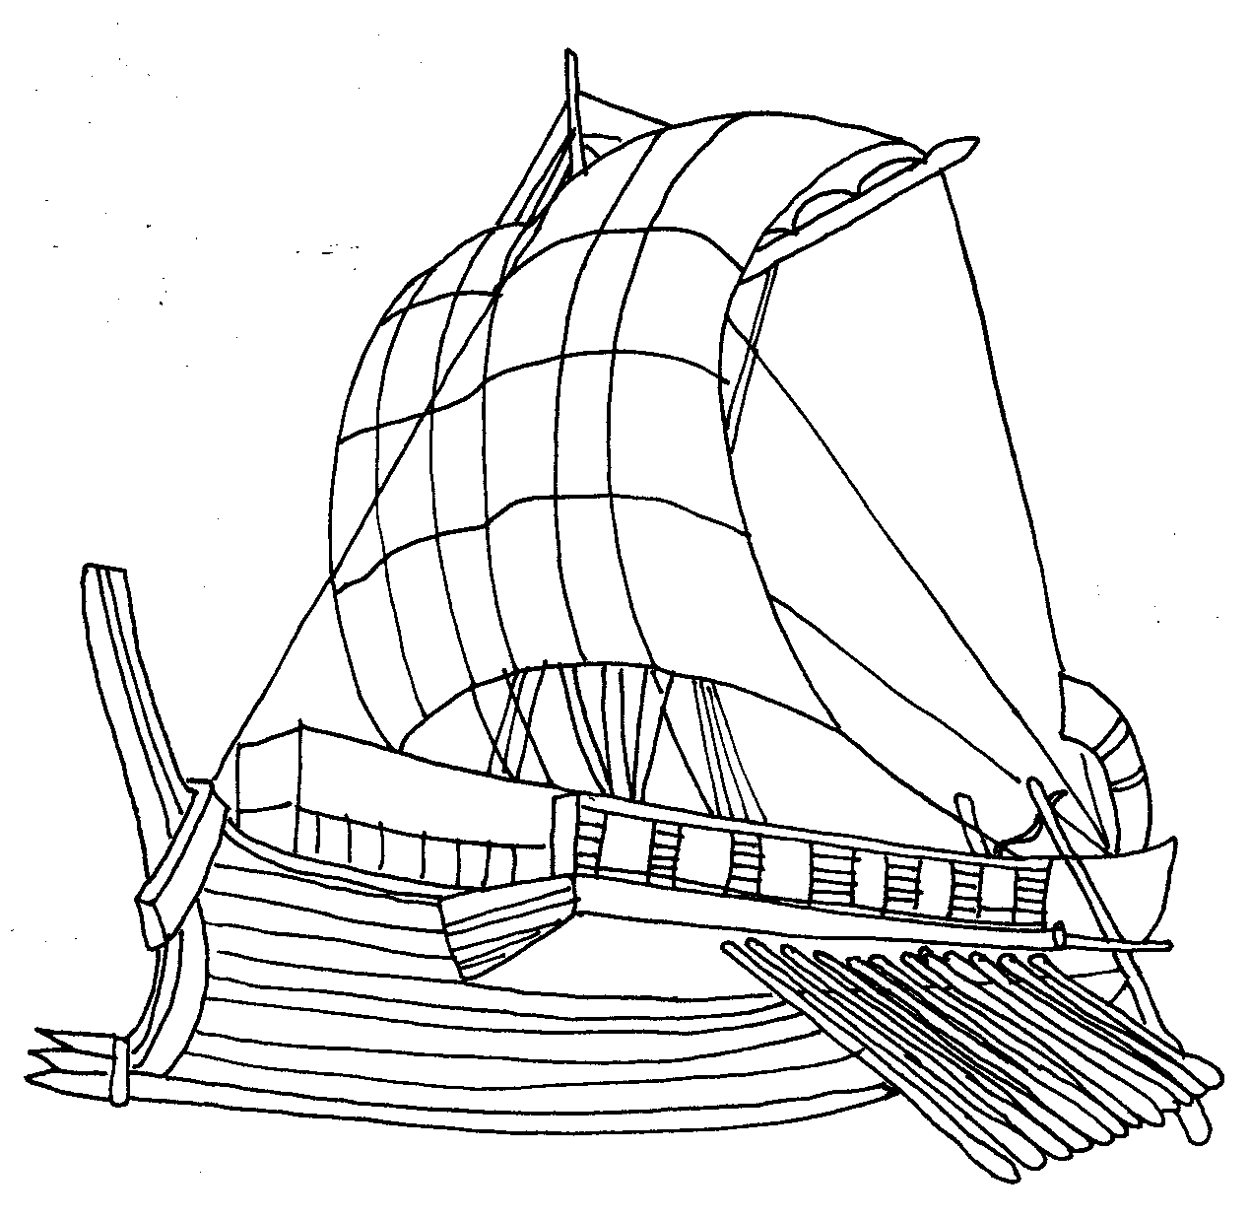

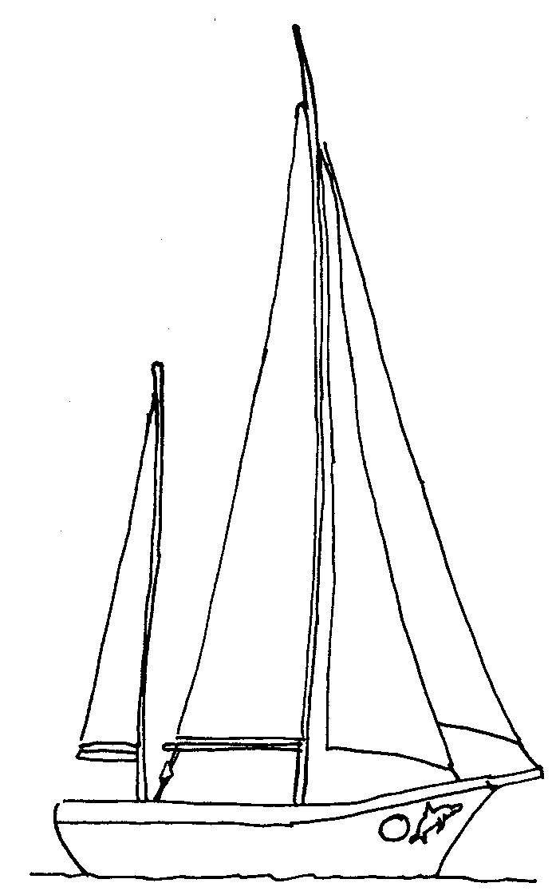

24

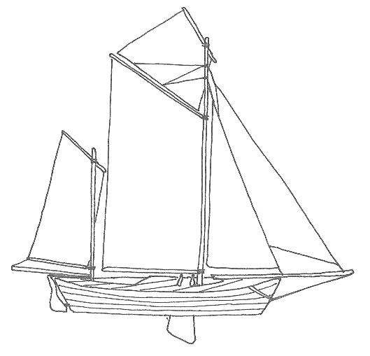

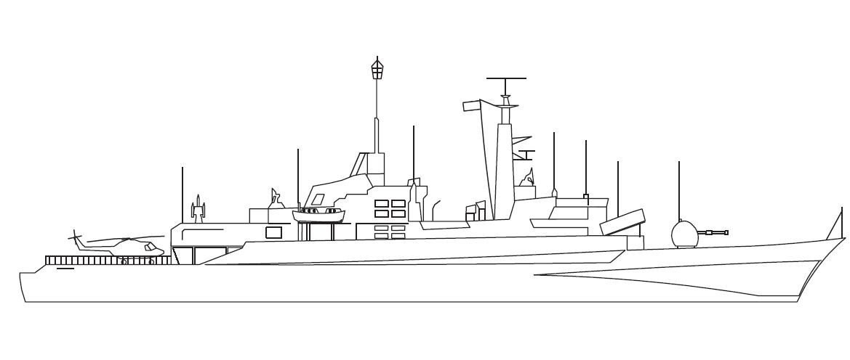

-1

-3

-4

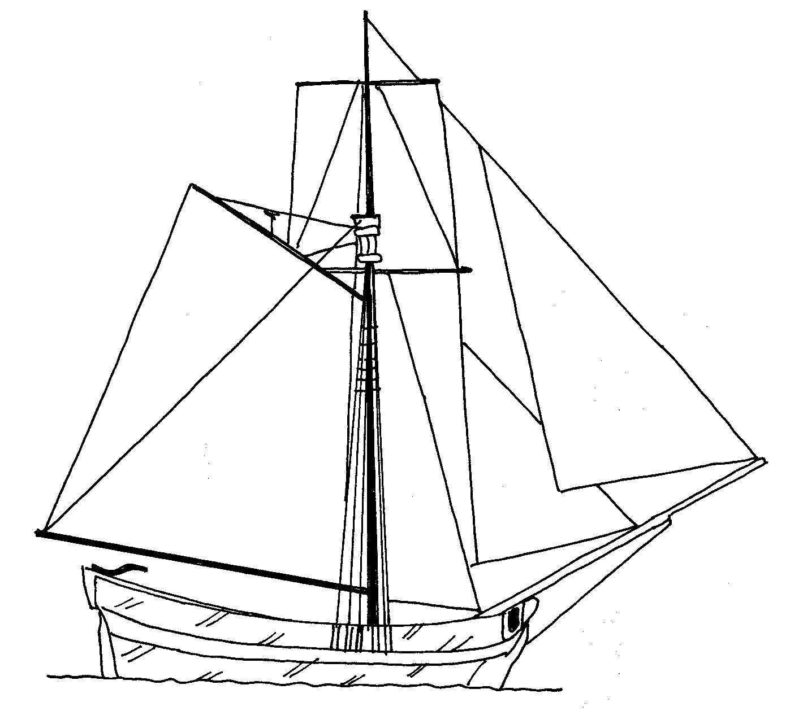

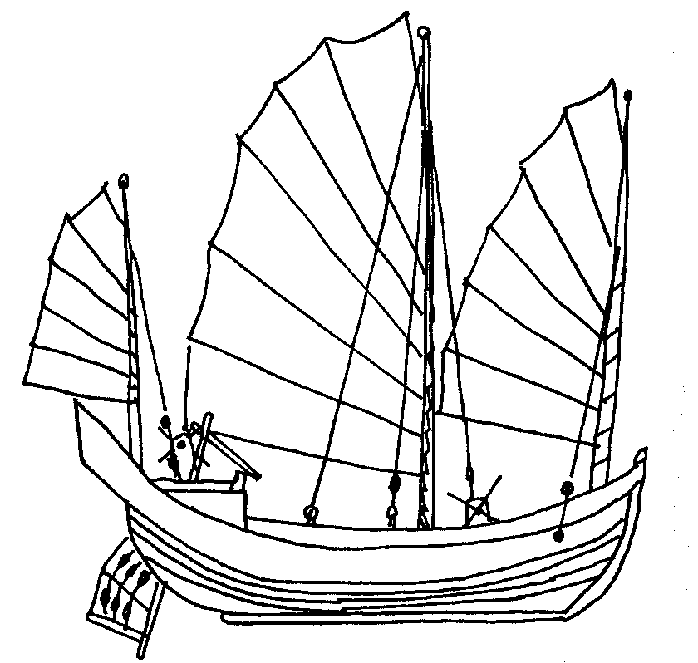

11

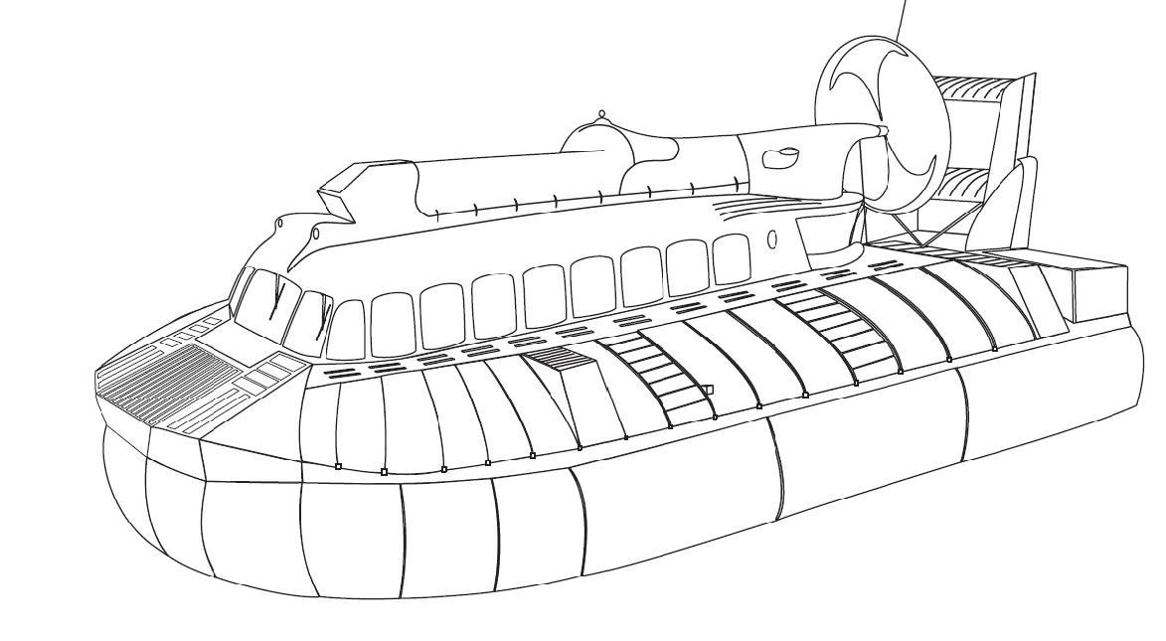

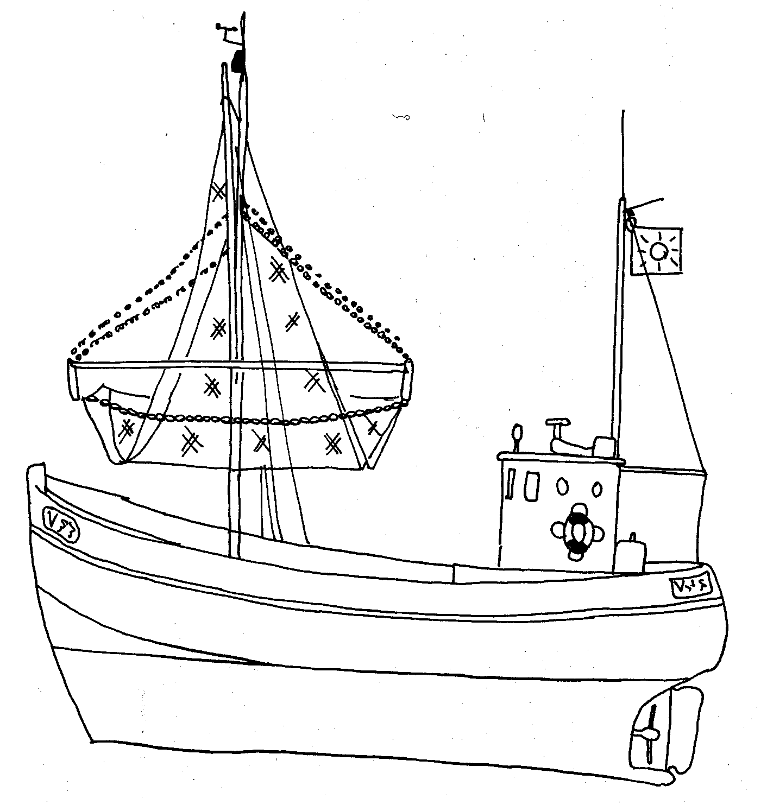

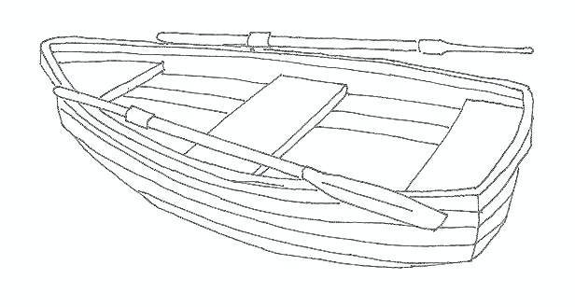

-14

-10

2

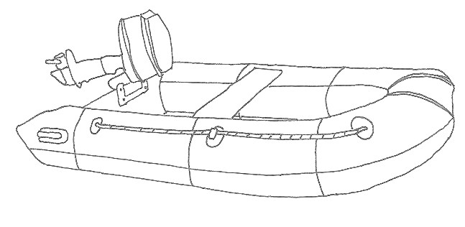

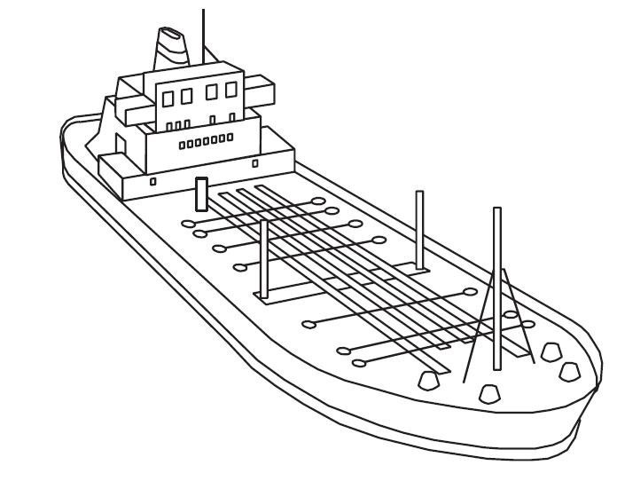

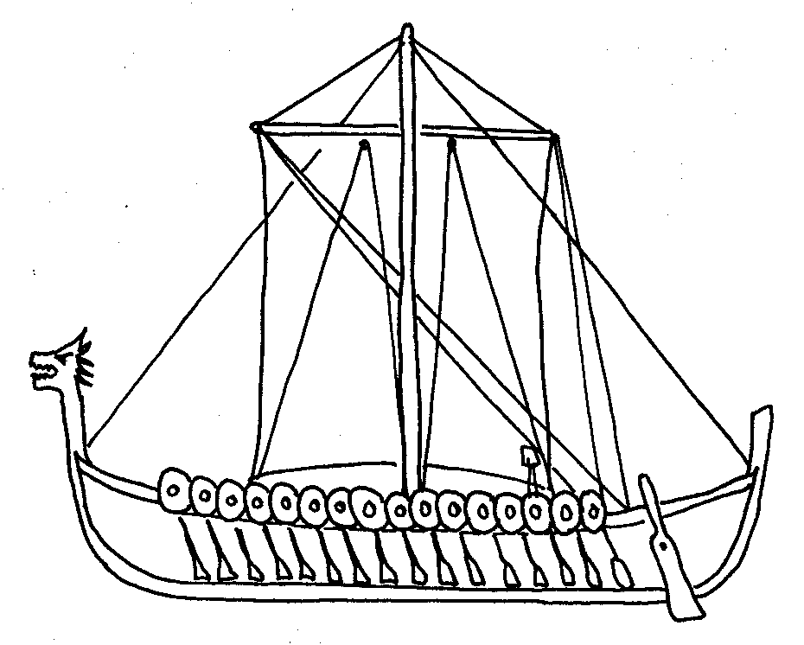

5

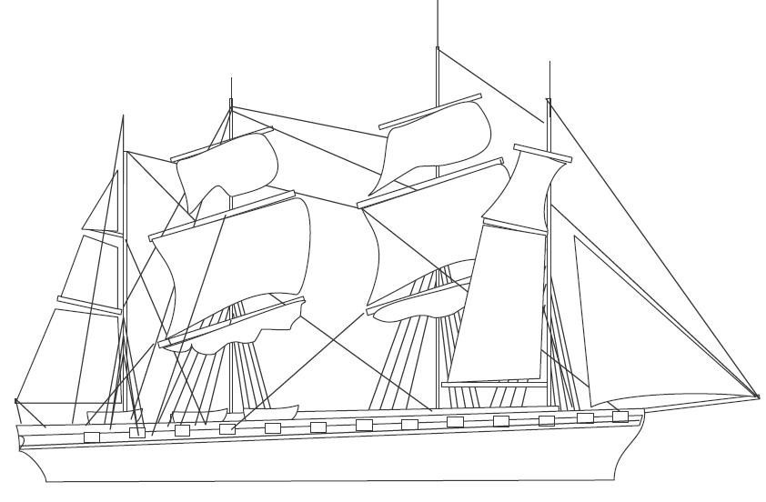

9

**Elaborado por:** Beatriz Villagrán Walter